NAME:

General Biology BIO121
Virtual Yeast Fermentation Lab: Part 1

Use RED font for your answers!

Introduction
This assignment is designed to assess your understanding of the scientific method as it applies to experimentation. As such, please review sections 1.4 – 1.6 in your textbook, and the associated Powerpoints from ch. 1. Be sure to understand the following terms: hypothesis, prediction, independent variable, dependent variable, positive control, negative control, conclusion.
Organisms stay alive by the utilization of energy through metabolism. Photosynthesis converts solar into the chemical energy of carbohydrates. This process is limited to autotrophs (producers), which include plants, photosynthetic bacteria and some protists. Carbohydrates are then used in energy releasing metabolic pathways: glycolysis, fermentation, aerobic respiration and anaerobic respiration. Catabolism of a molecule of 6-carbon glucose to two 3-carbon pyruvate molecules is an anaerobic process, which occurs in the cytoplasm and is termed glycolysis. The energy releasing pathways all start with glycolysis and the fate of the pyruvate depends on the cell type and environmental conditions.

Cellular respiration is the aerobic process whereby cells can extract the potential chemical bond energy of glucose, or other fuel sources such as lipids or proteins, and convert that energy into the potential chemical bond energy of ATP. Per molecule of glucose, the ATP yield is 36-38 ATP molecules depending on the cell type.

Oxygen is not available in all environments. Marshes, bogs, deep-sea sediments, the animal gut, canned foods and sewage treatment ponds are some anaerobic environments. Aerobic cellular respiration is not an option and organisms living in these conditions practice anaerobic glycolysis and fermentation. Some of these fermenter organisms die if exposed to oxygen, such as the bacteria responsible for the diseases of botulism and tetanus. Other kinds of fermenters are indifferent to the presence of oxygen, such as the lactobacillus used to manufacture yogurt. Still others can use oxygen, if available, and also practice fermentation when oxygen is limited, such as your muscle cells or yeasts.

Fermentation yields no new ATP, but allows for the regeneration of NAD+ox to be used in glycolysis (Figure 1). Glycolysis produces the net yield of two ATP's per molecule of glucose (Step 1 in Figure 1). This allows an organism to continue to convert energy for its cellular metabolic activities. Fermentation yields enough energy to sustain many single celled anaerobic organisms. Fermentation even aids some aerobic cells through times of stress, but does not provide enough energy to sustain a large, active multicellular organism.

There are two types of fermentation: lactic acid fermentation and alcohol fermentation. In lactic acid fermentation, pyruvate (pyruvic acid) is converted into lactate (lactic acid) using the electrons and hydrogens from NADHred + H⁺ and liberating NAD⁺ox. The regenerated NAD⁺ can return to the glycolysis pathway. Examples include the manufacture of cheese, yogurt and sauerkraut. Lactate fermentation also occurs in human muscle cells under decreased oxygen conditions. This is advantageous only for a short duration because fermentation depletes the
glucose stores and provides little ATP return for the investment. When glucose stores are depleted, muscles become fatigued and loose their ability to contract.

In today’s lab, yeast, single-celled fungi, will be utilized to observe alcoholic fermentation products. Different strains of yeast are used for different fermentation processes. Some examples include Saccharomyces cerevisiae for the rising of bread dough and S. ellipsoideus, a wild type yeast, used for wine and beer production. In alcohol fermentation, pyruvate (pyruvic acid) is converted into ethanol and carbon dioxide using the electrons and hydrogens from NADHred + H⁺ and liberating NAD⁺ox. The regenerated NAD⁺ can return to the glycolysis pathway.

Shown below is a schematic of the breakdown of glucose by glycolysis and the conversion of the resulting pyruvate molecules to ethanol. Note that ATP is generated only in the glycolysis portion, but fermentation is needed to regenerate the oxidized form of NAD+.
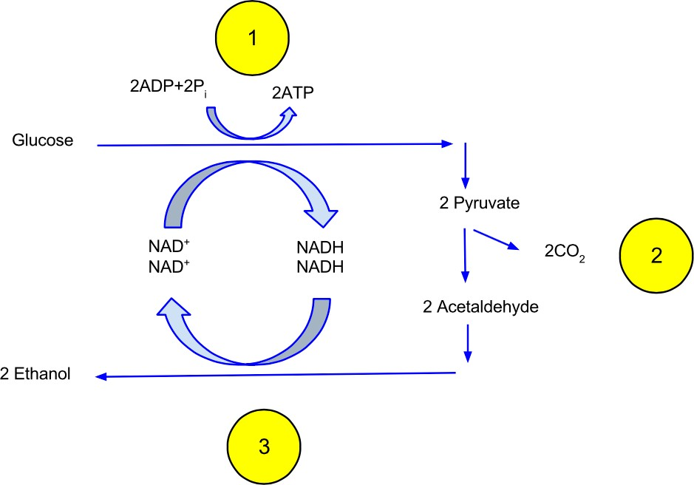
Figure 1 Ethanol Fermentation (David Carmack)

Baker's yeast, Saccharomyces cerevisiae, can utilize both anaerobic and aerobic methods. If the concentration of carbohydrates is high, therefore providing a plentiful food source, the yeast will use alcoholic fermentation for their energy requirements. The ability of yeast to ferment is strictly dependent on the carbohydrate source. Sucrose and glucose are suitable for fermentation, but lactose and galactose are not suitable due to lack of some of the enzymes necessary in the metabolic pathways.

This experiment will utilize a variety of carbohydrate substrates upon which the yeast may act. The measure of the carbon dioxide bubbles will be an indirect measurement of the ability of the yeast to perform fermentation.

- Which enzyme enables yeast to use sucrose for fermentation? What is the function of this enzyme. Cite two reliable resources.

- What is the function of Lactaid/lactase? Use and CITE two reliable resources.

- As a scientist, you are tasked with determining the best substrate for fermentation in yeast. You will test glucose, sucrose, galactose, lactose, and lactose in the presence of Lactaid. Design your experiment. How will you test fermentation rates in yeast? Be sure to include your control(s), independent variable(s), and dependent variable(s).

- Form a hypothesis AND make a prediction the rate of fermentation when glucose is used as a substrate (remember – you write your prediction as “If….then…..” based on your hypothesis. This helps you design experiments.)

Hypothesis:
Prediction:
- Form a hypothesis AND make a prediction about the rate of fermentation when sucrose is used as a substrate.

Hypothesis:

Prediction:

- Form a hypothesis AND make a prediction about the rate of fermentation when galactose is used as a substrate.

Hypothesis:

Prediction:

- Form a hypothesis AND make a prediction about the rate of fermentation when lactose is used as a substrate.

Hypothesis:

Prediction:

- Form a hypothesis AND make a prediction the rate of fermentation when lactose is used as a substrate when lactase is present.
Hypothesis:
Prediction:

Virtual Yeast Fermentation Lab: Part 2

Use RED font for your answers!

The Experiment

As a scientist, you are studying the rates of fermentation in yeasts using different substrates. In four test tubes you add a different substrate to live yeast cells, except for Tube 5 which contains water. Every 15 minutes, you measure the amount of glucose that is present in the tube and the amount of carbon dioxide (CO₂) that has been generated. After one hour, you analyze your results. Please answer the questions using the data in the table below.

 | Tube 1  Glucose |  | Tube 2  Sucrose |  | Tube 3  Lactose |  | Tube 4  Lactose + Lactase |  | Tube 5  Water
Minutes | mg/dl of Glucose | ml  of  CO₂ | mg/dl of Glucose | ml  of  CO₂ | mg/dl of Glucose | ml  of  CO₂ | mg/dl of Glucose | ml  of  CO₂ | mg/dl of Glucose | ml  of  CO₂
0 | 2000.00 | 0.00 | 0.00 | 0.00 | 0.00 | 0.00 | 0.00 | 0.00 | 0.00 | 0.00
15 | 1000.00 | 1.00 | 1000.00 | 0.25 | 0.00 | 0.25 | 250.00 | 0.50 | 0.00 | 0.00
30 | 1000.00 | 2.00 | 1000.00 | 1.00 | 0.00 | 0.25 | 500.00 | 0.75 | 0.00 | 0.00
45 | 500.00 | 2.50 | 2000.00 | 1.50 | 0.00 | 0.25 | 1000.00 | 1.50 | 0.00 | 0.00
60 | 200.00 | 3.00 | 2000.00 | 2.00 | 0.00 | 0.50 | 1000.00 | 2.00 | 0.00 | 0.00

- What is the independent variable(s)?

- What is the dependent variable(s)?

- What is the positive control(s)?

- What is the negative control(s)?

- Examine the data for glucose (Tube 1). What is the relationship between glucose concentration and CO₂ production?

- Examine the data for lactose and then lactose + lactase (Tube 4). How did the addition of lactase affect fermentation rates? Why?

- Explain the differences in fermentation rates between the substrates. In other words, explain why some worked better than others.

- In a real-world laboratory, one set of experiments is usually not sufficient. Scientists must repeat and modify experiments. What would you do next? Briefly describe an appropriate follow-up experiment to the one described above. Be sure to include a hypothesis, make a prediction, and indicate controls.

